

Prince George’s Community College
Intercollegiate Athletics and Intramural Emergency Action Plan (EAP)
August 2022

Table of Contents
Table of Contents
Personnel Involved in Development 3
The following individuals were involved with the creation of the Athletics EAP: 3
Documentation of Recent Changes 3
Introduction 3
Staff Education 6
Chain of Command 6
Emergency Telephone Numbers 7
Emergency Situation Contact Tree 8
Emergency Equipment Locations 9
General Plan of Action 9
Novak Field House Gymnasium 10
Novak Hall AED Locations 11
Soccer Game Field 12
Baseball Field 13
Track/Soccer Practice Field 14
Softball Game Field 15
Outdoor AED Locations 16
Annual Athletics EAP In-Service 17
Documentation of Seasonal Coaches’ Educational Meeting 17
Approval and Verification Page: 18

Personnel Involved in Development

The following individuals were involved with the creation of the Athletics EAP:

- Isaac Fields, Head Athletic Trainer
- JoAnn Todaro, Athletic Director
- Alex Mohseni MD

Documentation of Recent Changes
As changes to the EAP are made, please list the change, page affected and date that the change was made.
Specific Changes Made | Page(s) Affected | Date
*add rows as necessary

Athletics EAP OVERVIEW

Introduction
Emergency situations may arise at any time during athletic events. Expedient action must be taken in order to provide the best possible care to the student-athlete. The development, implementation and management of the Athletics EAP is designed to help ensure that the best care will be provided.
As emergencies may occur at any time and during any activity, all college personnel must be prepared to provide support. Athletic organizations have a duty to develop an EAP that may be implemented immediately when necessary and provide appropriate standards of emergency care to all sports participants. This preparation involves formulation of an EAP, proper coverage of events, maintenance of appropriate emergency equipment and supplies, utilization of appropriate sports medicine personnel, and continuing education in the area of sports medicine, emergency medicine, and planning. Through careful pre-participation physical screenings, adequate medical coverage, safe practice and training techniques, and other safety avenues, some potential emergencies may be averted. However, accidents and injuries are inherent with sports participation, and proper preparation on the part of the sports medicine team should enable each emergency situation to be managed appropriately and efficiently.
Components of an EAP
- Emergency Personnel
- Emergency Communication
- Emergency Equipment
- Roles of First Responders
- Venue Directions with a Map
- EAP Checklist for Non-Medical Emergencies
Emergency Personnel
The first responder in an emergency situation during an athletic practice or competition is typically a member of the sports medicine staff, such as a certified athletic trainer (ATC). However, the first responder may also be a coach or another member of the college staff.
Certification in cardiopulmonary resuscitation (CPR), first aid, automated external defibrillator (AED), as well as an EAP review is required for all athletics personnel associated with practices, competitions, skills instructions, and strength and conditioning [including: athletic director, college nurse, certified athletic trainer, head coaches, etc.]. Copies of training certificates and/or cards should be maintained with the athletic director. All coaches are required to have CPR, First Aid, and AED training certifications.
The emergency team consists of the team physician, certified athletic trainers, emergency medical technicians, coaches, managers, and possibly even bystanders. Roles of these individuals will vary depending on different factors such as team size, athletic venue, personnel present, etc.
The four basic roles within the emergency team are:
- Establish scene safety and immediate care of the athlete:
  - Medical care should be provided by the most qualified individual on the emergency team (the certified athletic trainer). All coaches and athletic administration staff are responsible for assisting the certified athletic trainer with any medical assistance and keeping the emergency scene clear of bystanders or players.
- Activation of Emergency Medical Services:
  - This may be necessary for situations where emergency transportation is not already present at the sporting event. Time is the most critical factor and this should be done by a member of the athletic administration.
- Equipment Retrieval:
  - Should be done by the assistant coaches or anyone on the emergency team who is familiar with the types and locations of the specific equipment needed.
- Direction of EMS to the scene:
  - Public Safety is in charge of meeting the emergency personnel as they arrive at the college. They will escort the emergency personnel to the scene and should have keys to locked gates/doors.

Activating Emergency Medical Services
Have two people, if able, call Public Safety (301-546-0111) and EMS (9-1-1) concurrently.
Provide information
- Name, location (if on campus include what building or field), telephone number of caller
- Nature of the emergency (medical or non-medical)*
- Number of athletes
- Condition of athlete(s)
- First aid treatment initiated by the certified athletic trainer or first responder
- Inform EMS that public safety will meet them at the closest entrance to the campus
- Other information requested by the dispatcher
- DO NOT HANG UP FIRST
*if non-medical, refer to the specified checklist of the school’s non-athletics emergency action plan

Emergency Communication
Communication is key to a quick, efficient emergency response. Access to a working telephone line or other device, either fixed or mobile, should be assured. There should also be back-up communication in effect in case there is a failure of the primary communication. At every athletic venue, home and away, it is important to know the location of a workable telephone. If needed, campus blue lights can be utilized to contact public safety.
Medical Emergency Transportation
Any emergency situation where there is loss of consciousness (LOC), or impairment of airway, breathing, or circulation (ABCs) or there is a neurovascular compromise should be considered a “load and go” situation and emphasis is placed on rapid evaluation, treatment, and proper transportation. Any emergency personnel who experiences doubt in their mind regarding the severity of the situation should consider a “load and go” situation and transport the individual.
Non-Medical Emergencies
For the non-medical emergencies (fire, bomb threats, violent or criminal behavior, etc.) refer to the college EAP and follow instructions.
Post EAP Activation Procedures:
Documentation
Documentation must be done by the certified athletic trainer (or other provider) immediately following activation of the EAP.

Debriefing
A team comprising of the ATC, Athletic Director, coach(es), nurse and one other college employee not involved with the situation must discuss the event within 48 hours. This team must evaluate the effectiveness of the EAP and conduct a staff debriefing. A specific timeline for changes to EAP should be made for promptness.

Conclusion
The importance of being properly prepared when athletic emergencies arise cannot be stressed enough. A student-athlete’s survival may hinge on the training and preparation of the emergency team. It is prudent to invest athletic department “ownership” in the EAP by involving the athletic administration and coaches as well as sports medicine personnel. The EAP should be reviewed at least once a year with all athletic administration staff, head coaches, public safety, and local emergency response teams. Through development and implementation of the emergency plan, Prince George’s Community College helps ensure that the athlete will have the best care provided when an emergency situation does arise.

Staff Education

- Every coach will receive a copy of the EAP and will be required to keep it in their possession during every practice/event.
  - Each coach will provide their signature to confirm they have read the documents and asked any potential questions.
- A copy of the EAP will be posted on the Prince George’s Community College athletics webpage.

Chain of Command

The athletic training should always act as primary care-givers at the site of the injury or accident (when on-site) and would manage the situation according to the following rank:
- Certified athletic trainer
- PGCC Nurse
- Emergency Services/Public Safety
- Athletic Director
- Athletic Administration Staff
- Head Coach
In the event that a certified athletic trainer is not on-site at the time of injury the following chain of command would be used:
- PGCC Nurse
- Emergency Services/Public Safety
- Athletic Director
- Athletic Administration Staff
- Head Coach

Emergency Telephone Numbers
This list is only to be used in case of an emergency.
Off Campus Contacts | Phone Number
PGCC DPS Communications Center  Emergency line  Non-emergency line | 301-546-0111  301-546-0666
Police department | 9-1-1
Fire and Ambulance | 9-1-1
[Nearest] Hospital | Where: 901 Harry S Truman Dr, Largo, MD 20774  Name: UMMC Emergency Room  Phone number: (240) 677-2000
[Second Nearest] Hospital | Where: 1221 Mercantile Ln, Upper Marlboro, MD 20774  Name: Kaiser Permanente Emergency Room  Phone number: (301) 618-5500

On Campus Offices | Phone Number
Athletic Training Room | 301-546-7026
Nurse | 301-546-0845
Athletic Director | 301-546-0066
Administrative Office | 301-546-0513
School Counselor Office | 301-546-0845

Title | Name
Athletic Trainer | Isaac Fields
Athletic Director | JoAnn Todaro

Emergency Situation Contact Tree
Injury or Sudden Illness
Coach or First Responder on Scene
CARE
Life Threatening Condition
Head Coach
*Assistant Coach or Administrative Staff get the AED
Call EMS and Public Safety
Call Certified athletic trainer
Call
Athletic
Trainer
Provide care until Athletic Trainer or EMS arrives.
Do not leave victim.
Provide proper first aid and care until athletic trainer arrives.
Do not leave victim.
CARE
CARE
CARE
Non-Life-Threatening Condition
CHECK
Second
First

Certified athletic trainer may at their discretion contact a sports medicine physician for guidance

Emergency Equipment Locations
Emergency Equipment:
- Athletic Training Kit, Splint Bag, AED on site for events covered by ATC
- First Aid Kit located with coach when traveling
      - AED
        - Located with ATC for all covered events
        - Additional AED located outside Novak Hall Gymnasium in lobby and in the baseball press box
      - Nearest phone
        - Certified athletic trainer’s personal cell phone when covering events
        - Coaches’ personal cell phones
        - Nearest emergency blue light box (reaches public safety only)
      - Splints
        - With ATC during events, in the baseball press box, or in the Athletic Training Room, Novak Hall Rm 123
      - Spine boards/Cervical Collar
        - Will be provided by EMS upon arrival
      - Bio-hazard Materials
        - Disposal Bin – in the Athletic Training Room, Novak Hall Rm 123

General Plan of Action
- Most medically qualified person will lead
- Check the scene – is it safe to help?
- Is the athlete breathing? Conscious? Pulse?
  - If NO instruct person (or two if available) to call 911 and public safety concurrently –
LOOK PERSON DIRECTLY IN EYES and make sure they call!
  - Instruct public safety to meet the ambulance at S Campus entrance in order to direct the ambulance to the appropriate site
- Perform emergency CPR/First Aid
  - If severe bleeding – control bleeding prior to CPR, if needed
- Instruct assistant coach, athlete, or bystander to get AED
- Instruct a player or assistant coach to contact the certified athletic trainer of Prince George’s Community College if they are present at the school, but not on the scene
- Instruct administrative staff, referees, or bystanders to control any crowd forming
- Contact Athletic Director
- Once the Certified athletic trainer or EMS arrives on the scene, assist with care as necessary
- Assistant coach must accompany athlete to hospital – either in the ambulance or follow by car
- Document the event

Novak Field House Gymnasium
Activate the EAP:
- Any loss of consciousness
- Possible Spine Injury
- Dislocation, Open Fracture, Displaced Closed Fracture
- Difficulty or absent breathing or pulse
- Immediate mental health concern
- Uncertainty of if you have a medical emergency

Emergency Personnel:
Prince George’s Community College Athletic Trainer will be on-site for all events and the majority of practices as well as in direct communication with the coaching staff. For emergencies during practices/games not covered, the EAP should be activated immediately.

Emergency Procedures:
- Check the scene
  - Is it safe for you to help?
  - What happened?
  - How many victims are there?
  - Can bystanders help?
- Instruct an administrative staff member, bystander, or a student-athlete to call 911 and Public Safety
  - Provide the following information
    - Who you are
    - General information about the injury or situation
    - Where you are (Provide: name, location of downed athlete, address, telephone #, number of individuals injured, type of injury that has occurred, treatment given, specific directions*).
    - Any additional information
    - *STAY ON THE PHONE, BE THE LAST TO HANG UP*
- Have Public Safety meet the ambulance at the S. Campus entrance and direct them to the appropriate site. Public Safety will:
  - Open Appropriate Gates/Doors
  - Designate an individual to "flag down" and direct to scene
  - Control injury site, limit care providers, etc.
- Perform emergency CPR/First Aid
  - Check airway/breathing/circulation, level of consciousness, and severe bleeding.
- If the certified athletic trainer is present he/she will stay with the athlete and provide immediate care.
- If the certified athletic trainer is not present, the most qualified coach (training/certifications) will stay with the athlete and provide immediate care.
      - If not on scene, contact the Prince George’s Community College Athletic Trainer
- Instruct the assistant coach to GET AED!!
    - Located in the hallway outside of room 104 or in the athletic training clinic (room 123).
- Designate officiating staff or bystanders to assist public safety in crowd control as needed
- Assist ATC and/or EMS with care as directed
- An assistant coach must go with the athlete to the hospital or follow in a car if not allowed in the ambulance
- Document event and debrief

Prince George’s Community College

Novak Hall AED Locations
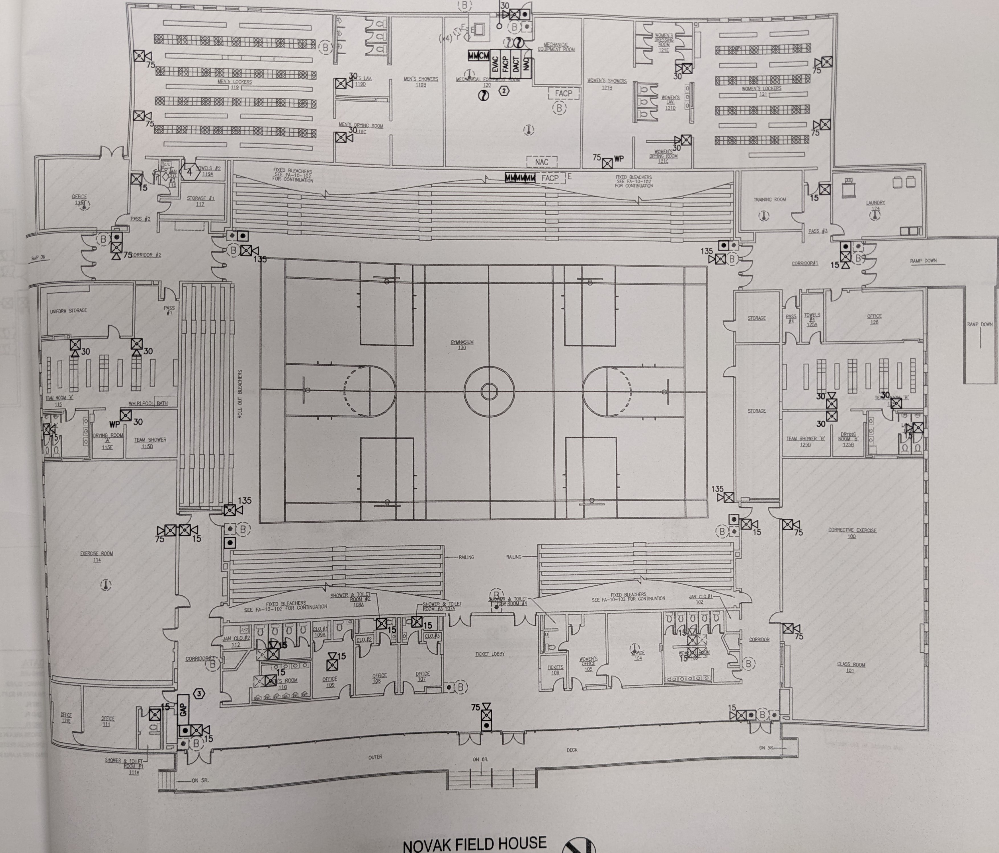
AED
AED

Soccer Game Field
Activate the EAP:
- Any loss of consciousness
- Possible Spine Injury
- Dislocation, Open Fracture, Displaced Closed Fracture
- Difficulty or absent breathing or pulse
- Immediate mental health concern
- Uncertainty of if you have a medical emergency

Emergency Personnel:
Prince George’s Community College Athletic Trainer will be on-site for all events and the majority of practices as well as in direct communication with the coaching staff. For emergencies during practices/games not covered, the EAP should be activated immediately.

Emergency Procedures:
- Check the scene
  - Is it safe for you to help?
  - What happened?
  - How many victims are there?
  - Can bystanders help?
- Instruct an administrative staff member, bystander, or a student-athlete to call 911 and Public Safety
  - Provide the following information
    - Who you are
    - General information about the injury or situation
    - Where you are (Provide: name, location of downed athlete, address, telephone #, number of individuals injured, type of injury that has occurred, treatment given, specific directions*).
    - Any additional information
    - *STAY ON THE PHONE, BE THE LAST TO HANG UP*
- Have Public Safety meet the ambulance at the S. Campus entrance and direct them to the appropriate site. Public Safety will:
  - Open Appropriate Gates/Doors
  - Designate an individual to "flag down" and direct to scene
  - Control injury site, limit care providers, etc.
- Perform emergency CPR/First Aid
  - Check airway/breathing/circulation, level of consciousness, and severe bleeding.
- If the certified athletic trainer is present he/she will stay with the athlete and provide immediate care.
- If the certified athletic trainer is not present, the most qualified coach (training/certifications) will stay with the athlete and provide immediate care.
      - If not on scene, contact the Prince George’s Community College Athletic Trainer
- Instruct the assistant coach to GET AED!!
    - Located in the baseball press box or in the certified athletic trainer’s vehicle
- Designate officiating staff or bystanders to assist public safety in crowd control as needed
- Assist ATC and/or EMS with care as directed
- An assistant coach must go with the athlete to the hospital or follow in a car if not allowed in the ambulance
- Document event and debrief

Baseball Field
Activate the EAP:
- Any loss of consciousness
- Possible Spine Injury
- Dislocation, Open Fracture, Displaced Closed Fracture
- Difficulty or absent breathing or pulse
- Immediate mental health concern
- Uncertainty of if you have a medical emergency

Emergency Personnel:
Prince George’s Community College Athletic Trainer will be on-site for all events and the majority of practices as well as in direct communication with the coaching staff. For emergencies during practices/games not covered, the EAP should be activated immediately.

Emergency Procedures:
- Check the scene
  - Is it safe for you to help?
  - What happened?
  - How many victims are there?
  - Can bystanders help?
- Instruct an administrative staff member, bystander, or a student-athlete to call 911 and Public Safety
  - Provide the following information
    - Who you are
    - General information about the injury or situation
    - Where you are (Provide: name, location of downed athlete, address, telephone #, number of individuals injured, type of injury that has occurred, treatment given, specific directions*).
    - Any additional information
    - *STAY ON THE PHONE, BE THE LAST TO HANG UP*
- Have Public Safety meet the ambulance at the S. Campus entrance and direct them to the appropriate site. Public Safety will:
  - Open Appropriate Gates/Doors
  - Designate an individual to "flag down" and direct to scene
  - Control injury site, limit care providers, etc.
- Perform emergency CPR/First Aid
  - Check airway/breathing/circulation, level of consciousness, and severe bleeding.
- If the certified athletic trainer is present he/she will stay with the athlete and provide immediate care.
- If the certified athletic trainer is not present, the most qualified coach (training/certifications) will stay with the athlete and provide immediate care.
      - If not on scene, contact the Prince George’s Community College Athletic Trainer
- Instruct the assistant coach to GET AED!!
    - Located in the baseball press box or in the certified athletic trainer’s vehicle
- Designate officiating staff or bystanders to assist public safety in crowd control as needed
- Assist ATC and/or EMS with care as directed
- An assistant coach must go with the athlete to the hospital or follow in a car if not allowed in the ambulance
- Document event and debrief

Track/Soccer Practice Field
Activate the EAP:
- Any loss of consciousness
- Possible Spine Injury
- Dislocation, Open Fracture, Displaced Closed Fracture
- Difficulty or absent breathing or pulse
- Immediate mental health concern
- Uncertainty of if you have a medical emergency

Emergency Personnel:
Prince George’s Community College Athletic Trainer will be on-site for all events and the majority of practices as well as in direct communication with the coaching staff. For emergencies during practices/games not covered, the EAP should be activated immediately.

Emergency Procedures:
- Check the scene
  - Is it safe for you to help?
  - What happened?
  - How many victims are there?
  - Can bystanders help?
- Instruct an administrative staff member, bystander, or a student-athlete to call 911 and Public Safety
  - Provide the following information
    - Who you are
    - General information about the injury or situation
    - Where you are (Provide: name, location of downed athlete, address, telephone #, number of individuals injured, type of injury that has occurred, treatment given, specific directions*).
    - Any additional information
    - *STAY ON THE PHONE, BE THE LAST TO HANG UP*
- Have Public Safety meet the ambulance at the S. Campus entrance and direct them to the appropriate site. Public Safety will:
  - Open Appropriate Gates/Doors
  - Designate an individual to "flag down" and direct to scene
  - Control injury site, limit care providers, etc.
- Perform emergency CPR/First Aid
  - Check airway/breathing/circulation, level of consciousness, and severe bleeding.
- If the certified athletic trainer is present he/she will stay with the athlete and provide immediate care.
- If the certified athletic trainer is not present, the most qualified coach (training/certifications) will stay with the athlete and provide immediate care.
      - If not on scene, contact the Prince George’s Community College Athletic Trainer
- Instruct the assistant coach to GET AED!!
    - Located in the baseball press box or in the certified athletic trainer’s vehicle
- Designate officiating staff or bystanders to assist public safety in crowd control as needed
- Assist ATC and/or EMS with care as directed
- An assistant coach must go with the athlete to the hospital or follow in a car if not allowed in the ambulance
- Document event and debrief

Softball Game Field
Activate the EAP:
- Any loss of consciousness
- Possible Spine Injury
- Dislocation, Open Fracture, Displaced Closed Fracture
- Difficulty or absent breathing or pulse
- Immediate mental health concern
- Uncertainty of if you have a medical emergency

Emergency Personnel:
Prince George’s Community College Athletic Trainer will be on-site for all events and the majority of practices as well as in direct communication with the coaching staff. For emergencies during practices/games not covered, the EAP should be activated immediately.

Emergency Procedures:
- Check the scene
  - Is it safe for you to help?
  - What happened?
  - How many victims are there?
  - Can bystanders help?
- Instruct an administrative staff member, bystander, or a student-athlete to call 911 and Public Safety
  - Provide the following information
    - Who you are
    - General information about the injury or situation
    - Where you are (Provide: name, location of downed athlete, address, telephone #, number of individuals injured, type of injury that has occurred, treatment given, specific directions*).
    - Any additional information
    - *STAY ON THE PHONE, BE THE LAST TO HANG UP*
- Have Public Safety meet the ambulance at the S. Campus entrance and direct them to the appropriate site. Public Safety will:
  - Open Appropriate Gates/Doors
  - Designate an individual to "flag down" and direct to scene
  - Control injury site, limit care providers, etc.
- Perform emergency CPR/First Aid
  - Check airway/breathing/circulation, level of consciousness, and severe bleeding.
- If the certified athletic trainer is present he/she will stay with the athlete and provide immediate care.
- If the certified athletic trainer is not present, the most qualified coach (training/certifications) will stay with the athlete and provide immediate care.
      - If not on scene, contact the Prince George’s Community College Athletic Trainer
- Instruct the assistant coach to GET AED!!
    - Located in the baseball press box or in the certified athletic trainer’s vehicle
- Designate officiating staff or bystanders to assist public safety in crowd control as needed
- Assist ATC and/or EMS with care as directed
- An assistant coach must go with the athlete to the hospital or follow in a car if not allowed in the ambulance
- Document event and debrief

Prince George’s Community College

Outdoor AED Locations
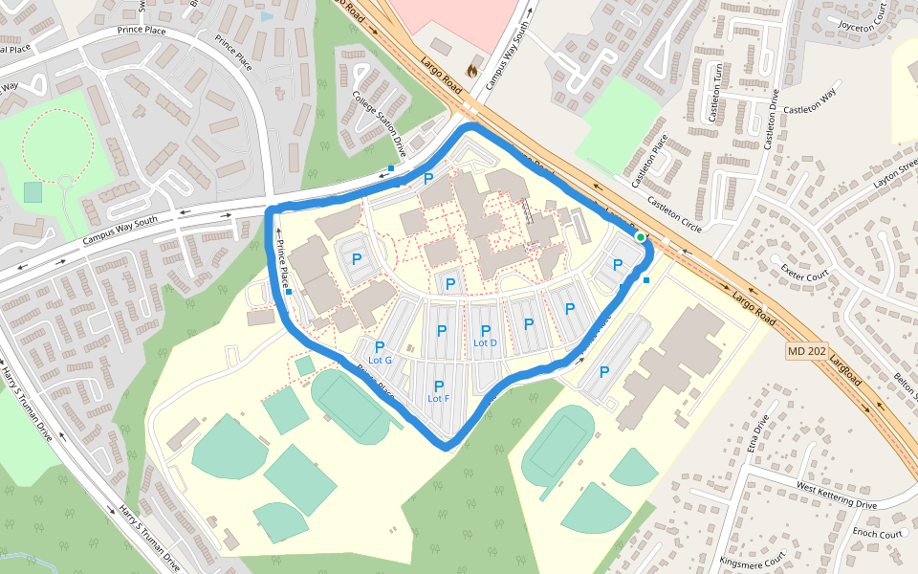
AED
AED

Annual Athletics EAP In-Service

The certified athletic trainer will be responsible for reviewing the EAP annually and hosting the EAP Inservice prior to/at the beginning of each school year.
Coaches at Prince George’s Community College will be educated on the EAP during the EAP Inservice which is a requirement for the head coaches of each sport.
The EAP Inservice will include a PowerPoint presentation for recent updates, as applicable, along with a hands-on portion. The hands-on portion will run through different scenarios to ensure the coaches understand and feel confident in the roles as dictated by the EAP. All attendees will be provided the opportunity to ask any and all questions and the certified athletic trainer will be responsible for ensuring a proper and adequate answer to all questions.
All coaches must sign in to prove their attendance, see the following page. The documentation of attendance will be stored with the certified athletic trainer.
The athletic director will be provided with a copy of the EAP and will be required to attend the EAP Inservice along with the coaches and the remainder of the athletic administrative staff. Athletic administrative staff must sign in to prove attendance.

Documentation of Seasonal Coaches’ Educational Meeting
Topic: EAP Rehearsal
Sign in Sheet
Coach Name (printed) | Sport | Signature
Notes:

Approval and Verification Page:
This document has been read and revised by the Prince George’s Community College athletic trainer, team physician and athletic director.
Certified athletic trainer: ______________________________________ Date: _____________________
Athletic Director: _____________________________________ Date:_____________________

---------------------------------------------------------------------------------------------------------------------------------------------------
I _____________________________________________________________(print coach name/sport) have read and understand the EAP for Prince George’s Community College Athletics. I understand my roles and responsibility should an emergency occur in my presence. I have also rehearsed this EAP and understand my role in an emergency situation with a certified athletic trainer present and without. I have been given the opportunity to ask all questions and have received the proper answers to my questions.
I also understand that I must keep my CPR/AED and First Aid Certifications up to date and that it is my responsibility to ensure a lapse does not occur.

Coach Name (print)_________________________________________ Sport _________________________

Signature _________________________________________________ Date _________________________

